**Yellow Instructions** Name:_________________________

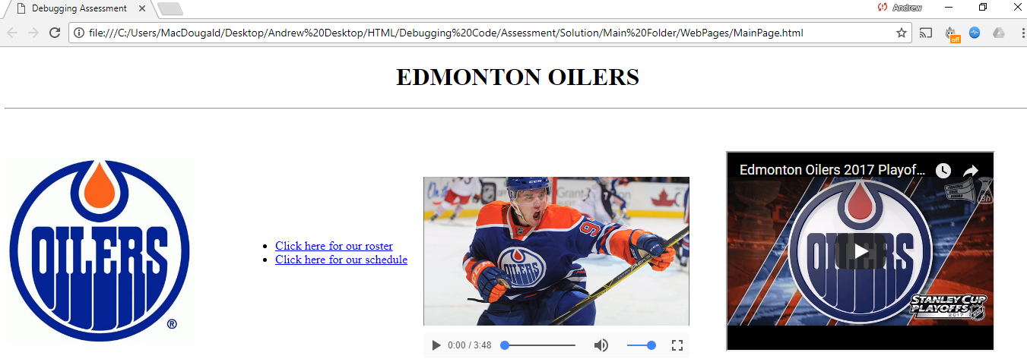

Clicking on image takes user to a website

Youtube video

Video with controls (no autoplay or loop)

Unordered list with two links.

H1 header, centered

Horizontal line followed by 2 line breaks

Title

The webpage should look as above. There are 12 errors to debug. You may use the files to try and fix the webpage. Circle the errors and write the corrections on the sheet of paper. The website address for the links and Youtube video are correct.

<!Doctype html>

<head>

<!--Created by Mr. MacDougald

Modified by Mr. Pauls

CMP 621A HTML Debugging Assignment-->

<meta charset="UTF-8">

<meta name="description" content="Debugging assignment">

<meta name="keywords" content="CMP521A, debug, debugging html assignment">

<meta name="author" content="Mr. Pauls">

<meta name="viewport" content="width=device-width, initial-scale=1.0">

<title>Debugging Assessment< title>

</head>

<body>

<h1 style="text-align:center;">EDMONTON OILERS</h2>

<hr />

<br />

<br />

<table style="width:100%;">

<tr>

<td style="width:20%;">

<a href="https://www.nhl.com/oilers" target="_blank"> <img width="245 height="245" src="Images/oilers_logo2.jpg" alt="Oilers Homepage">

</a>

</td>

<td style="width:15%;">

<ol>

<li> <a href="https://www.nhl.com/oilers/roster" target="_blank"> Click here for our roster </a></li>

<li><a href="https://www.nhl.com/oilers/schedule/2020-03-01/AT" target=" blank"> Click here for our schedule</a></li>

</ol>

</td>

<td style="width:20%;">

<video width="350" height="280" controls>

<source src="./Media/mcdavidgoals.mp4" type="video/mp4">

Your browser does not support the video tag.

</video>

</td>

<td style="width:20%;"

<iframe width="350" height="260" src="https://www.youtube.com/embed/4rea9ruCLAU">

</td>

</tr>

</table>

</html>